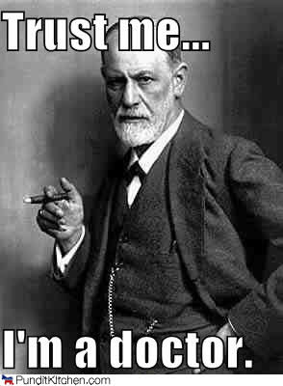
Is Freud Void?
A Nursery Rhyme of Sorts
By Hilary Gunby
Pursue pleasure, avoid pain.
Is this why Sigmund used cocaine?
People have their opinions about dear old Freud,
But you can decide if his theory is void:

With our Ego in charge, we must be realistic.
Not a Superego superhero, or sexually ballistic.
Yes, within the Id a problem lies.
Dreams of penises and milky thighs,
Society unwilling to compromise,
Fantasies of Mom buried deep inside…
We need old Freud to be our guide!
In fact, with him, we cannot hide.
Defense mechanisms? Don’t even try.
For he knows the root of everything:
Mom’s teat, attractive parents, and our toilet training.
With his help we explore- our entire self.
All it takes is five years (and unlimited wealth).
What’s that you say? You disagree?
His disciples did too, as you soon shall see.

Sullivan said, “Don’t call clients hysterical!
‘Problems in living’ is so much more bearable.”
Jung said, “Freud, the world is more than one person.
It is far more inclusive to treat with my version.
Sex-crazed biology is not all that we are.
Our spirit and culture, now these are the stars.”
“Transference as projection?” considered Kohut.
“It’s idealization; your idea, KAPUT!”

As time passed, Freud’s theory changed more.
Self-awareness, here and now, began to take the floor.
Interpersonal relationships, trauma, and shame,
Brief and affordable: the names of the game.
Now the client must learn to problem solve.
Pure dependence on the therapist, it must dissolve.
Although Freud’s theory hasn’t proved effective,
It does not mean it’s completely defective.
There are terms and ideas still valued today:
Resistance, catharsis, repression at play.
It is still acknowledged: interpreting dreams,
And knowing the surface is not as it seems.
They indeed hold true, those childhood patterns,
Insecurity, attachment; it all still matters.

So say what you want about dear old Freud,
But it’s hard to describe him as null and void.

